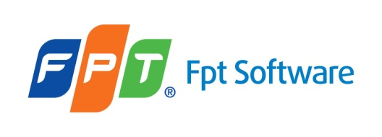

**Luong Trung Hieu**

**PERSONAL DETAILS**

* Name **Luong Trung Hieu**
* Nationality Vietnamese
* Date of birth 26/07/1996
* Sex Male
* Marital status Single
* Phone No. 0819607196
* Email HieuLT22@fsoft.com.vn

**EDUCATIONAL BACKGROUND**

* UNIVERSITY OF COMMUNICATIONS AND TRAJNSPORT

**CERTIFICATE AND AWARD**

**PROFESSIONAL SUMMARY**

* team work skills
* reading professional documents
* be active and find a way to solve problems quickly
* listen and consider right and wrong to improve skills

**SOFTWARE**

* Object-Oriented-Programming (2 years of use)
* C# Language (3 years of use)
* Programming Languages – C# .NET [MVC, Core] (Intermediate)
* JQuery, HTML, AJAX, CSS (Intermediate)
* Angular(Beginner)
* LINQ(2 year of use)
* Databases - SQL Server, MySQL (3 years of use)

**OPERATING SYSTEMS**

* Windowns

**PROFESSIONAL EXPERIENCE**

**10/2018- 12/2019**

**Software Developer at FPT Software-HCM**

**Project:** P3

**Project Description**:

Complete construction of an ERP system (Enterprise Resource Planning) for famous Japanese small and medium enterprises, on the .Net Web platform with the most advanced Front End technology Angular 4 within three years. Customers of the company are companies listed on the stock exchange, specializing in ERP solution packages (enterprise resource management) for small and medium enterprises in the land of the rising sun.

**Responsibilities**:

* Study Requirement from customer
* Complete the assigned screen
* Create project structure
* Review source code.

**Technologies Used**:

Software environment

•        C#

•        Angular 6

Development tools

•        Visual Studio

* Visual Code
* Git Extensions

**01/2019- 04/2019**

**Software Developer at FPT Software-HCM**

**Project:** PDI (Pickup Delivery Image)

**Project Description**:

Develop PDI application based on below items: App using Web Application. Support Drive Delivery at Vietnam.

**Responsibilities**:

* Study Requirement from customer
* Create project structure
* Review source code.

**Technologies Used**:

Software environment

•        C# MVC .NET Core

•        Angular 6

Development tools

•        Visual Studio

* Visual Code
* Git Extensions